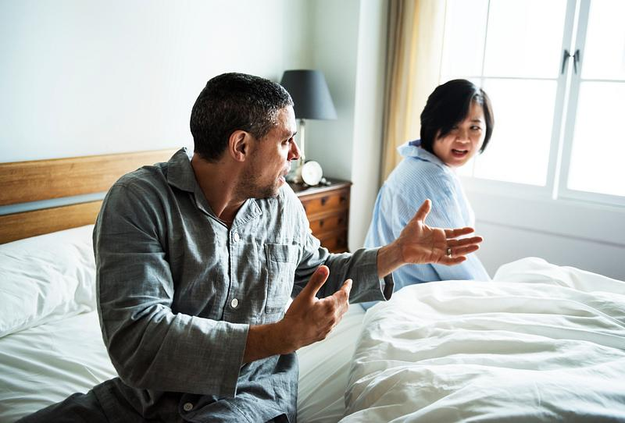
Restoring Safety, Connection, and Trust (From the Inside Out)
Relationships are not only emotional. They are physiological.
When couples experience conflict, disconnection, or unresolved resentment, it is often the nervous systems involved that are dysregulated.
Our couples work focuses on restoring safety at the nervous system level so connection can naturally return.

Why Traditional Couples Therapy Often Falls Short
Many couples already know what the issues are.
They’ve talked.
They’ve analyzed.
They’ve argued their points clearly.
Yet their bodies remain reactive, guarded, or shut down.
This happens because relational pain is stored not just in memory but in the body.
Until the nervous system feels safe, meaningful connection remains out of reach.
A Somatic & Nervous System–Centered Approach to Relationships
Our couples work goes beyond communication strategies to address how partners experience each other in their bodies.
This approach supports couples in:
- understanding emotional chemistry
- recognizing survival responses in relationships
- restoring felt safety and attunement
- dissolving stored anger and resentment
- rebuilding trust through embodied experiences
Healing happens when partners learn to regulate together.

What Our Work Looks Like
Couples sessions may include guided, experiential practices designed to restore connection without blame or escalation.
Somatic Awareness in Relationships
Partners learn to recognize how their bodies respond to one another, noticing tension, withdrawal, activation, or shutdown without judgment.
This awareness becomes the foundation for change.

Synchronized Breathing & Regulation
Couples are guided through shared breathing practices that support nervous system alignment, co-regulation, and emotional softening.
This helps reduce reactivity and rebuild a sense of safety together.

Couples Meditation & Alpha State Induction
Guided meditative practices support couples in entering calmer, more receptive states where repair and connection become possible.
These practices help partners experience each other without defensiveness.

Rewriting Relational Body Narratives
Partners learn how the body holds relational memory and how intentional practices can help release old patterns and create new experiences of connection.
This work focuses on repair, not revisiting harm.

Who This Work Is For
Couples work may be supportive if you:
- feel emotionally distant despite wanting closeness
- experience recurring conflict or resentment
- struggle with trust or safety
- want to reconnect beyond surface communication
- are open to experiential, body-based approaches
This work is not about assigning fault. It’s about restoring connection.

A Respectful, Ethical Approach
Couples are never forced into vulnerability, confrontation, or emotional exposure.
All practices are introduced with consent, pacing, and respect for each partner’s capacity.
The goal is not intensity — it is safety.

Come Closer: Relationship Healing
Our couples work may be offered through individual sessions, structured series, or immersive experiences designed to deepen connection over time.
If you’re unsure whether this approach is right for you, we’re happy to help guide you.

